SOCIAL CASE STUDY REPORT
April 16, 2026

Control No. 055M-2026

- PERSONAL INFORMATION:
Name : JOVELYN QUINDOYOS
Address : Barangay Purock-A-Bassit, Vigan City, Ilocos Sur
Age : 53 years old
Civil status : Married
Occupation : Sari-Sari Store Proprietor
Religion : Roman Catholic
- FAMILY COMPOSITION:
NAME | AGE | RELATIONSHIP | OCCUPATION
Nhoj Karl Vincent Quindoyos | 34 | Son | Security Guard
Frincess Jovirose Quindoyos | 21 | Daughter | None (Schooling)
Myleen Dangcil | 42 | Daughter in Law | Online Selling
Queen Jovi Quindoyos | 10 | Granddaughter | None (Schooling)
Zerikah Quindoyos | 1 | Granddaughter | N/A
- PROBLEM PRESENTED:
Client came personally to the office seeking emergency financial assistance for her medical need and expenses as she was advised to undergo 2D Echo with Dopppler.
- FINDINGS:
Client and family lives at Barangay Purok-A-Bassit, Vigan City, Ilocos Sur. They belong to the less fortunate members of the community, earning below minimum income, which is hardly enough for their daily needs. Client was diagnosed with coronary artery disease; s/p percutaneous coronary intervention and was advised to undergo continuous medication and laboratory. The family is concerned about where to get money for her hospital expenses, since they had no other source of income and rely solely on the monthly earnings of Joel, which is hardly enough to cover her medical needs and expenses. Hence, they sought the assistance from the City Government to augment their financial problem. Thus, to help and lessen the burden they are suffering. The client is recommended for financial assistance for the payment of her hospital bill.
- EVALUATION/RECOMMENDATION:
In view of the above, undersigned recommends the subject to avail financial assistance from the City Government through Assistance to Individual in Crisis Situation Program in the amount of THREE THOUSAND PESOS ONLY (P3,000.00)

Prepared and submitted by:

RUBY ROSE GALLARDO-PAGAOA
Lab. Aide

Reviewed by:

REINALYN S. ALEGAR
Social Welfare Officer II
Recommending Approval:

MARIBELLE J. ARTIENDA
City Social Welfare and Dev’t. Officer
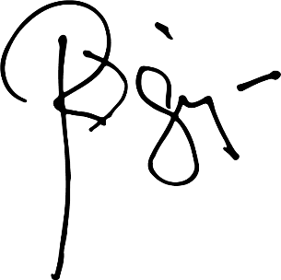
APPROVED:

HON. RANDOLF “RANDY” V. SINGSON
City Mayor

